*“Possessed of an excellent palate, and with an impeccable winemaking background, the quality of John’s wines is guaranteed.”* ***James Halliday*** *– Australian Wine Companion 2013*

Brilliant straw colour, with typical bottle ferment, aromas of fresh baked bread, and notes of mandarin peel and vegemite.

An outstanding crisp, bright, fresh palate with fine beading in the mouth. It has intense, nutty, bready and subtle stone fruit flavours. The wine has excellent length of flavour, with a soft crisp finish.

Extra time on lees compared to previous vintages has given the 2010 an extra degree of finesse and complexity. We are really pleased with this wine, and believe it is an excellent Australian bubbly – albeit truly Swan Valley in style.

**2010 CHARDONNAY   
BLANC DE BLANC**Swan Valley, WA

Early-picked Chardonnay (19th February) from our own vineyard is used to make this fine, tasty wine.   
The hand-picked fruit is whole-bunch fermented without crushing to achieve the most delicate juice possible.

The juice is quickly fermented and the wine stabilised. It was triaged in July 2010, and disgorged between   
26 and 35 months later.

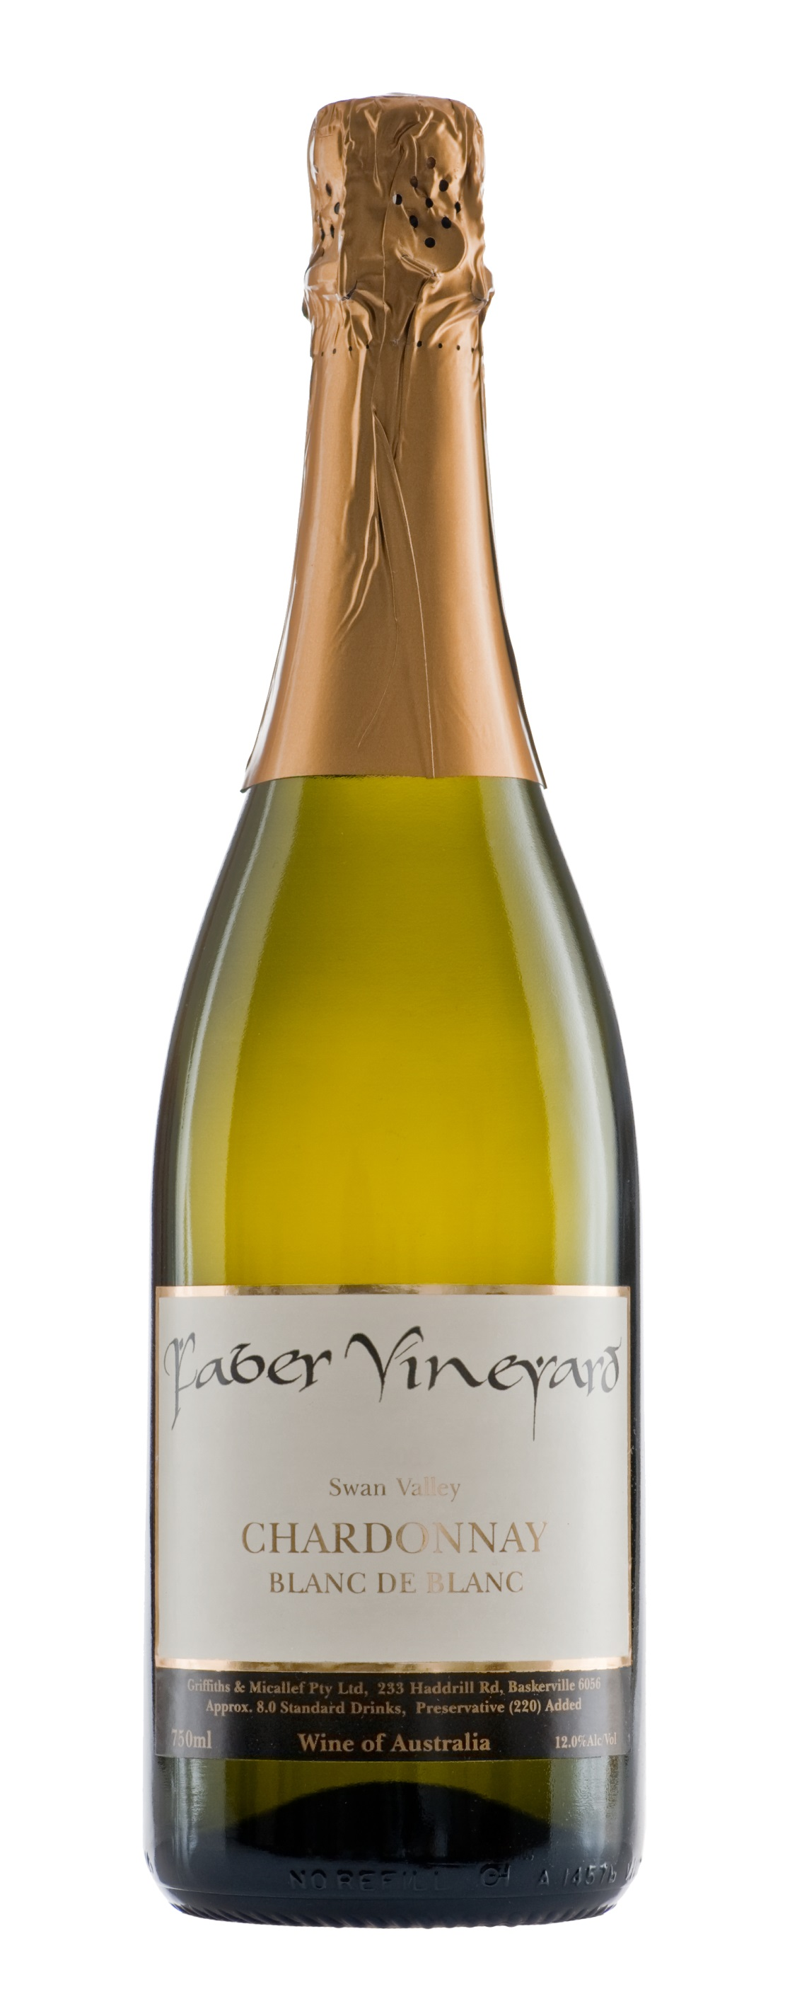

***Faber Vineyard was established in 1997 by well-known winemaker John Griffiths.   
The dream is to grow regionally distinctive grapes and craft wines that are rich and flavoursome***.

**233 Haddrill Road, Baskerville WA 6056**

**p: 08 9296 0209 f: 08 9296 0681 e: john@fabervineyard.com.au w: www.fabervineyard.com.au**

