*“From a single vineyard; extended maceration and subsequent French oak maturation has embellished the sweet cassis fruit of the wine.”*

***93 points****, Cellar 15 years*

***James Halliday***

**2010 FRANKLAND RIVER CABERNET** Frankland River, WA

Machine picked on the morning of the 8th April, the fruit was delivered to Faber and crushed later that same day. After fermentation in open vats the wine was racked to new French oak hogsheads and aged for 21 months. It was racked from oak and bottled in January 2013.

Each year we have been fortunate to be able to purchase a small quantity of excellent fruit from one of the state’s premier vineyards in Frankland. John has been very closely involved with this vineyard for over ten years, and really enjoys making this wine, which is so different to our Swan Valley Shiraz.

The wine is deep dark red in colour. There is a remarkable, intense nose of sweet blackcurrant, freshly crushed vine leaves and a hint of dusty, cedary oak.

The palate is hugely sweet-fruited, fine and elegant. There are intense blackcurrant flavours – the essence of Cabernet Sauvignon. It’s absolutely delicious. Fine grained tannins support the fruit flavour and give length.

Despite its power and intensity of flavour, the wine is surprisingly delicate – not heavy at all, with a very long, lingering finish.

Frankland Cabernet stands out for its sweet fruit flavours and great structure. Our aim for this wine is to make a fine and distinctive Cabernet Sauvignon that should age for ten years plus.

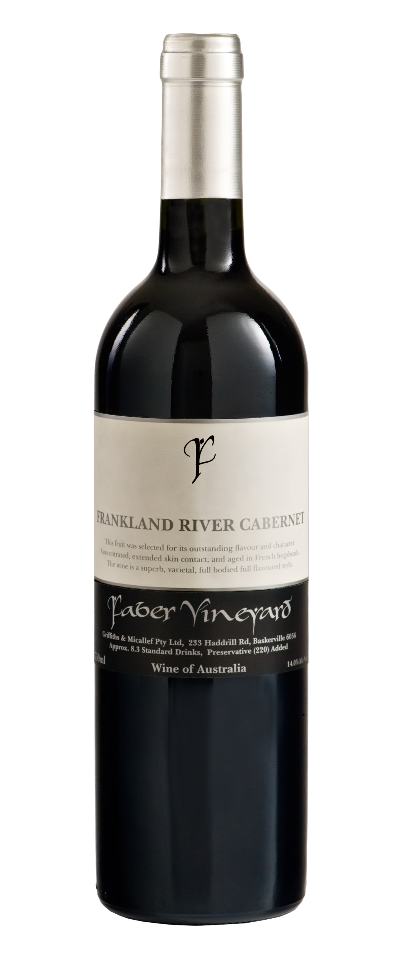

***Faber Vineyard was established in 1997 by well-known winemaker John Griffiths.   
The dream is to grow regionally distinctive grapes and craft wines that are rich and flavoursome***.

**233 Haddrill Road, Baskerville WA 6056**

**p: 08 9296 0209 f: 08 9296 0681 e: john@fabervineyard.com.au w: www.fabervineyard.com.au**

