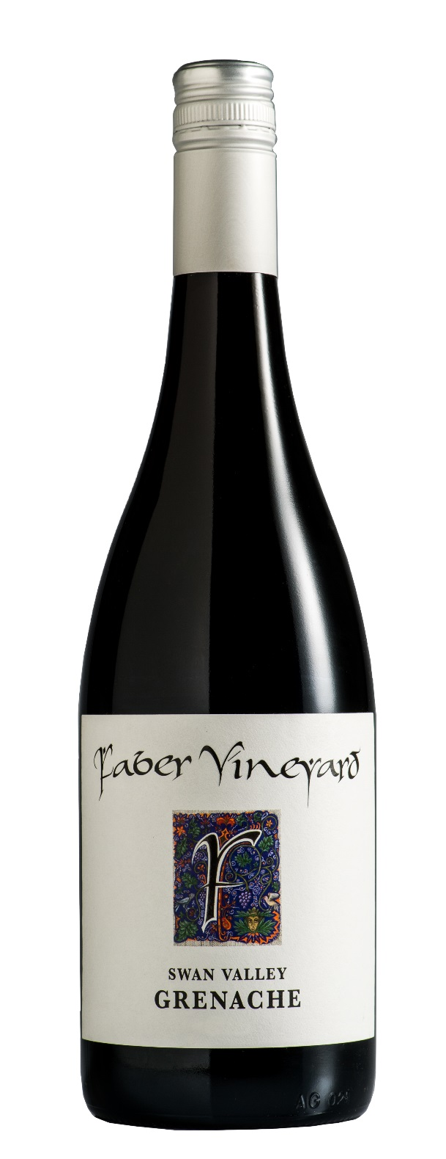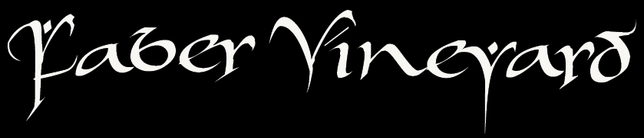

***faber n. (Latin) / fae-ber / craft, trade, skilful, dedicated, creative***

***Medium red in colour. It has distinctive perfumed***

***aromas of Grenache.-fresh cherries, rosehip and earth.***

***The palate has intense mouthfilling flavours of red***

***berries and cherry ripe. It has a bright and balanced***

***acidity followed by savoury dryness and a soft, chewy finish.***

***Pure expression of the fruit in the vineyard. It was handpicked from Sita Vineyard on Haddrill Rd, Baskerville. We discovered this fruit when sampling the vineyard with owner Andrew Pruno (whose grandfather Joe Sita planted the vines).***

***We elected to make an authentic Grenache, matured in old oak and was bottled early. Despite at first seeing a simple, light wine—it is in fact quite structured & savoury displaying excellent Grenache varietal character and style. We are very proud.***

*____________________________________________________*

Light in colour and pretty to smell. Shows a little sweet spiced banana oak, dusty musk Grenache perfume, red fruits, cherry cola and subtle dried herb. Light to medium bodied, savoury rather than fruit sweet but does have juicy red berry flavour, light playful kitten’s tongue tannin and even acidity that’s fresh, but unobtrusive. Clean length. Minor amount of warmth, but nothing overbearing. Lovely wine. Lively. Great to drink. Well done.

**92 points, drink 2014—2020, Gary Walsh—The Wine Front, April 2014**

**2013 Grenache**

***Swan Valley, WA***

***Faber Vineyard was established in 1997 by well-known winemaker John Griffiths. The***

***dream is to grow regionally distinctive grapes and craft wines that are rich and flavoursome.***

***Faber Vineyard was established in 1997 by well-known winemaker John Griffiths. The***

***dream is to grow regionally distinctive grapes and craft wines that are rich and flavoursome.***

*the craft of wine*