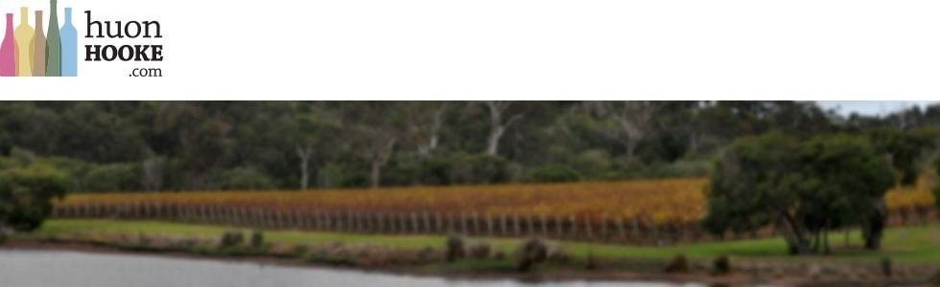
March 18, 2015
Give verdelho a chance
I’ve often expressed regret that so many wines are released (and presumably drunk) too young, before they’ve had a chance to show their full worth. Verdelho is a variety that is seldom treated seriously by critics and wine judges, but perhaps it hasn’t been given enough time.
I recently tasted the Faber Vineyard Swan Valley Verdelho 2009 (tasting), which at six years of age was a truly beautiful bottle of wine. The sample was sent to me with one of the current release: 2014. Faber is owned and run by the highly accomplished former Houghton winemaker John Griffiths (pictured above) and his wife Jane. They are great believers in warm-climate viticulture and grape varieties.
The wine is rich and complex, beautifully textured an balanced, and crammed full of buttered-toast and honey aromas and flavours. I scored it 95. I can see it drinking well for several more years.
The 2014 (tasting) is straightforward and drinks very well as a young, simple, but somewhat neutral dry white. Chances are, it will develop in a similar direction, especially as Griffiths believes ‘14 is a particularly good vintage. He has a small quantity of the 2009 which will be re-released as a museum release in the next year or two (no date has been set).
When I asked John about these wines, he pointed out that the 2006 had also been held back for further aging and re-released at $42 at cellar door last year. It had won the chairman’s trophy at the 2013 Swan Valley Wine Show.
Griffiths himself believes verdelhos like the 2014 are best at about one to two years, or else as aged wines (presumably he means at least six years).
“When I make verdelho I’m never really quite sure how good they are until they are about 12 months old,” he said. “It’s not uncommon to see beautifully developed verdelho here in the Swan. Houghton in the past occasionally held back some Moondah Brook for a museum release as a seven-year-old, and Westfield/John Kosovich have had a succession of beautiful aged releases. Whilst they are delicious simple, fruit-driven wines when young they really become something else again in four-plus years. I have seen these wines still beautiful up to 15 years old and I really think our 2009 is just on the start of its journey.”
Generously, he listed other makers of verdelho which age beautifully as Lamonts, Sittella and Mandoon (tastings). “Not every vintage will age so well, although these wines are all made similarly – moderately ripe fruit (alcohols 13 – 14%), moderate acidity, bright fresh fruit, medium to full-bodied, low phenolics. I believe the key is picking ripe enough to achieve a high degree of flavour, yet not too ripe so that the wine is fat and waxy (high alcohol protruding). It must be made from free-run only as it is a very phenolic variety and the pressings are crap. It’s a balancing act and when achieved the result can be as you see in the 2009.”
The way these wines mature with age is quite surprising: normally, white wines from warm to hot regions don’t reward cellaring – although Hunter Valley semillon and Clare Valley riesling are exceptions to the rule. Says Griffiths: “I do think the degree of change with age is quite surprising – I’m sure it’s not what one would
expect for a hot area white picked ripe – but I’ve seen enough to know that it is the norm. Most winemakers here take verdelho quite seriously because we have come to respect how good it can be – despite popular opinion (and we do know how crap it can be if not grown and handled with great care!). “Interestingly, these wines appeal to a pretty broad range of people in cellar door – from those who like dry crisp wines to those who like ‘fruity’ (sweet) wines.”

What Huon thinks….
Faber Swan Verdelho 2009
Light to medium yellow hue with a very attractive buttered-toasty, straw, mellowing bouquet which is quite complex and interest-filled. There's a trace of honey as well. There's a slight grip on the aftertaste but the generous flavour (and a faint suspicion of sweetness) provides balance. It really fills the mouth and finishes clean and dry. Because of the firmness it demands food - and would be a very good food wine. Bottle-age has transformed this into a really delicious and quite beautiful wine.
95 points, Drink to 2019

Faber Swan Verdelho 2014
Light yellow colour. Slightly sweaty yeasty as well as spicy aromas, then a broad and fruity palate with a touch of sweetness. A straightforward, generously proportioned white wine, with a touch of phenolic grip which adds backbone. What it lacks in finesse it makes up in amplitude.
88 points, Drink 2014 - 2020

